Depression: Clinical Features
- Perception (negative bias)
- Cognition (concentration, cognitive distortions, suicidal ideation, negative self-view)
- Mood (low, irritable, anxious, increased or decreased emotional reactivity, loss of interest)
- Somatic state (fatigue, appetite, aches, sleep difficulties, circadian rhythms)
- Behaviour (physical slowness, agitation, flat affect, self-harm)
- Relationships ( Withdrawal, conflict, less engagement with work or education)
Depression
- Sadness is not depression
- Both DSM V and ICD-10 require symptoms to have been present for at least two weeks
- Up to 25% of the population will experience depression
- Can be mild, moderate, severe, Seasonal Affective Disorder, melancholic or even psychotic depression.
- The concept of ‘reactive’ or ‘endogenous’ depression is contested.
- Research has shown combination of genetic and environmental vulnerabilities preceded by stressful events in all depression (Parker 2009)
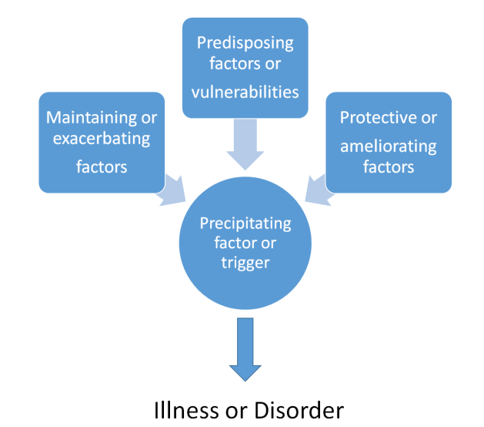

Predisposing factors
- Developmental (increased sensitivity)
- Genetic vulnerability
- Temperament
- Attachment history
- Loss and trauma
- Family factors
- Social and educational disadvantage
- Gender

Treatment

- NICE guidelines
- Two thirds can be helped by brief structured interventions (CBT, psychodynamic and systemic interventions)
- Guided self-help (Mood Juice) http://www.moodjuice.scot.nhs.uk/depression.asp
- Psycho education groups
- Antidepressant medication such as SSRIs (higher relapse rates if not linked to psychotherapy). Side effects.
- Multimodal interventions are most effective.
- Mindfulness
- Electro-convulsive therapy

